10 MARKS QUESTION
- Explain historical biological observations with reference to Brownian motion And thermodynamics
Historical Biological Observation: Robert Brown and Brownian Motion
- Robert Brown was a Scottish botanist who made an important historical contribution to biology through his observation of Brownian motion. In 1827, while studying pollen grains of the plant Clarkia pulchella under a microscope, Brown noticed that the pollen grains suspended in water showed a continuous, irregular, zig-zag movement.
- Initially, Brown thought this movement might be due to the pollen grains being alive. To test this, he repeated the experiment using inorganic particles such as dust, soot, and powdered glass.
- Surprisingly, these non-living particles also showed the same random movement. This confirmed that the motion was not due to life or vitality, but a physical phenomenon.
- This random motion was later named Brownian motion in honor of Robert Brown. Much later, scientists explained that Brownian motion occurs due to the constant and unequal collision of water molecules with the suspended particles.
- Since molecules are in continuous motion, they strike the particles from different directions, causing the irregular movement.
- The Big Breakthroughs
- Brownian motion isn't just a physics quirk; it actually proved that atoms and molecules exist.
- Robert Brown (1827): A botanist who noticed pollen grains in water moving jitterily under a microscope. He originally thought the pollen was "alive," but later realized even inorganic dust did the same thing.
- Albert Einstein (1905): In his "miracle year," Einstein published a paper providing the mathematical proof for Brownian motion. He showed that the movement could be predicted if you assumed the water was made of individual atoms.
- Jean Perrin (1908): He performed the experiments that confirmed Einstein’s math, effectively ending the debate over whether atoms were real or just a theoretical concept.
- the Origin of Thermodynamics
- Introduction
- Julius Robert Mayer (1814–1878) was a German physician and physicist who played a foundational role in the origin of thermodynamics. He is best known for proposing the law of conservation of energy and establishing the concept of mechanical equivalent of heat, which became the backbone of the First Law of Thermodynamics.
- Background and Key Observation – Detailed Explanation
- Mayer as a Ship’s Doctor
- Julius Robert Mayer was not a physicist by training; he was a medical doctor working as a ship’s physician. This is important because his discovery came from physiological observation, not a laboratory experiment.
- During his sea voyage, Mayer treated sailors in tropical regions, where the surrounding temperature was much higher than in Europe.
- Observation of Venous Blood Color
- Mayer noticed something unusual:
- The venous blood (blood returning to the heart) of sailors in the tropics appeared brighter red than expected.
- Normally, venous blood is dark red because it has already given up oxygen to body tissues.
- This observation raised a scientific question in his mind:
- Why is venous blood richer in oxygen in warm climates?
- Cold climate vs warm climate (key comparison)
- In cold climates
- Body loses more heat to the environment
- To maintain body temperature:
- Metabolic rate increases
- More oxidation of food occurs
- More oxygen is taken from hemoglobin
- Result:
- Blood returning to the heart has less oxygen
- Venous blood looks dark red
- In warm climates
- Body loses very little heat
- Less internal heat production is needed
- Therefore:
- Less oxidation of food
- Less oxygen consumption by tissues
- Result:
- More oxygen remains bound to hemoglobin
- Venous blood appears brighter red
- Significance of the Observation
- This single medical observation:
- Linked physiology, chemistry, and physics
- Led to the idea of energy conservation
- Became the conceptual foundation of the First Law of Thermodynamics

- Describe classification in biology: cellularity, ultrastructure, and nitrogen Excretion

Biological Classification Based on Cellularity, Ultrastructure, and Nitrogen Excretion
Biological classification helps organize living organisms based on shared characteristics. Three important criteria are cellularity, ultrastructure, and nitrogen excretion.

1. Classification Based on Cellularity
This refers to the number of cells that make up an organism.
- Unicellular organisms
  - Made up of a single cell
  - Perform all life processes within one cell
  - Examples: Bacteria, Amoeba
- Multicellular organisms
  - Composed of many cells
  - Show division of labor and specialization
  - Examples: Plants, Animals
👉 This distinction helps separate simple organisms from more complex ones.

2. Classification Based on Ultrastructure
Ultrastructure refers to the detailed internal organization of cells (seen under an electron microscope).
- Prokaryotic cells
  - No true nucleus (DNA is not membrane-bound)
  - Lack membrane-bound organelles
  - Smaller and simpler
  - Example: Bacteria
- Eukaryotic cells
  - Have a true nucleus
  - Contain membrane-bound organelles (mitochondria, ER, etc.)
  - Larger and more complex
  - Examples: Protists, Fungi, Plants, Animals
👉 This classification is fundamental in dividing life into major domains or kingdoms.

3. Classification Based on Nitrogen Excretion
Organisms are also classified based on the form in which they excrete nitrogenous waste.
- Ammonotelic organisms
  - Excrete nitrogen as ammonia
  - Ammonia is toxic but highly soluble in water
  - Requires large amounts of water
  - Examples: Aquatic animals like fish
- Ureotelic organisms
  - Excrete nitrogen as urea
  - Less toxic than ammonia
  - Requires moderate water
  - Examples: Mammals, amphibians
- Uricotelic organisms
  - Excrete nitrogen as uric acid
  - Least toxic and conserves water
  - Excreted as semi-solid paste
  - Examples: Birds, reptiles, insects
👉 This adaptation is closely related to habitat and water availability.

Conclusion
Classification based on cellularity, ultrastructure, and nitrogen excretion provides insight into the complexity, cellular organization, and physiological adaptations of organisms, helping in understanding evolutionary relationships.

- Give a detailed account of biomolecules as the chemical basis of life, including carbohydrates, proteins, and nucleic acids

Biomolecules as the Chemical Basis of Life
Biomolecules are organic compounds that form the structural and functional basis of living organisms. They are primarily composed of carbon, hydrogen, oxygen, nitrogen, phosphorus, and sulfur. The major classes include carbohydrates, proteins, and nucleic acids, each playing essential roles in maintaining life.

1. Carbohydrates
Carbohydrates are the most abundant organic molecules and serve as the primary source of energy.

Structure
They are composed of carbon, hydrogen, and oxygen in the general formula (CH₂O)ₙ.

Types
- Monosaccharides: Simple sugars (glucose, fructose)
- Disaccharides: Two monosaccharides (sucrose, lactose)
- Polysaccharides: Long chains (starch, glycogen, cellulose)

Functions
- Immediate energy source (glucose)
- Energy storage (starch in plants, glycogen in animals)
- Structural role (cellulose in plant cell walls)

2. Proteins
Proteins are complex macromolecules made of amino acids and are vital for structure and function.

Structure
- Composed of amino acids linked by peptide bonds
- Exhibit levels of organization: primary, secondary, tertiary, and quaternary structures

Functions
- Enzymes: Catalyze biochemical reactions
- Structural proteins: e.g., collagen
- Transport proteins: e.g., hemoglobin
- Regulatory proteins: hormones like insulin
- Defense proteins: antibodies
👉 Proteins are essential for almost all cellular activities.

3. Nucleic Acids
Nucleic acids store and transmit genetic information.

Types
- DNA (Deoxyribonucleic acid)
- RNA (Ribonucleic acid)

Structure
- Made up of nucleotides (nitrogenous base + sugar + phosphate)
- DNA has a double helix structure; RNA is usually single-stranded

Functions
- DNA stores hereditary information
- RNA helps in protein synthesis (mRNA, tRNA, rRNA)
They control cellular structure and function through gene expression.

Conclusion
Biomolecules such as carbohydrates, proteins, and nucleic acids are fundamental to life. They provide energy, structural integrity, and genetic continuity, forming the chemical foundation of all living organisms.

4. Write a brief note on glycolysis
Glycolysis is the fundamental metabolic pathway that breaks down glucose molecule into pyruvate molecules.
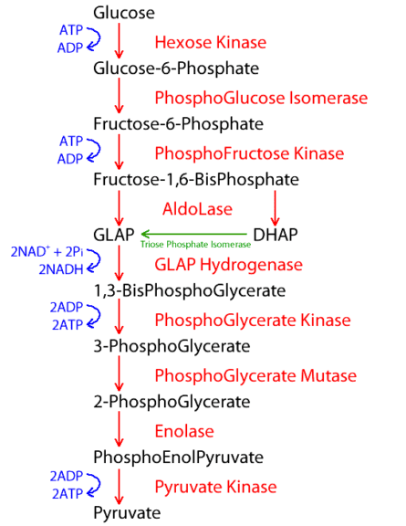
5. Explain Mendel’s laws of inheritance with suitable examples
. Law of Dominance (First Law)
This law states that when an organism has two different alleles (variants) for a trait, one allele (the dominant one) will mask the presence of the other (the recessive one) in the phenotype.
- Example: In pea plants, tallness (T) is dominant over dwarfness (t).
- Cross: A pure-breeding Tall plant (TT) × Pure-breeding Dwarf plant (t).
- F1 Generation: All offspring are (Heterozygous), but they are 100% Tall because masks.
2. Law of Segregation (Second Law / Law of Purity of Gametes)
This law states that the two alleles for a heritable trait separate (segregate) during gamete formation (meiosis) and end up in different gametes. Therefore, each gamete carries only one allele, and they recombine randomly during fertilization.
- Example: Crossing the offspring (Tt× Tt) from the example above.
- Gametes: Each Tt plant produces T and t gametes.
Generation (Punnett Square):
  - TT(Tall)
  - Tt (Tall)
  - Tt (Tall)
  - tt (Dwarf)
- Result: A 3:1 phenotypic ratio (3 Tall : 1 Dwarf) and a 1:2:1 genotypic ratio (TT: Tt: tt). The recessive trait (t) reappears.

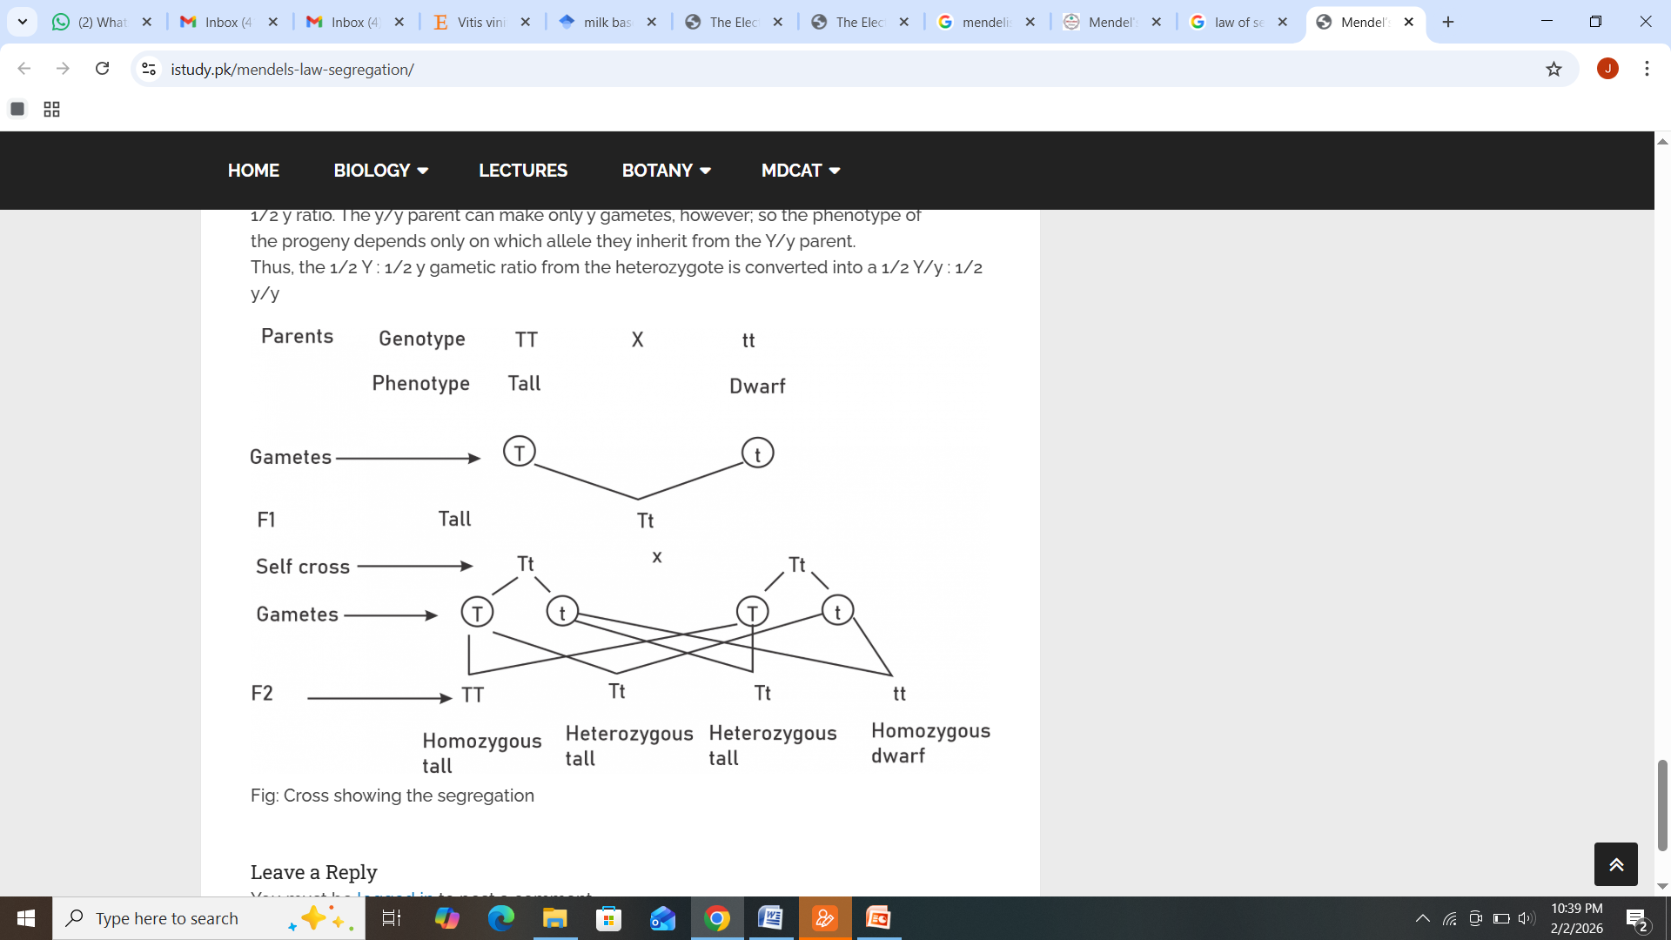
3. Law of Independent Assortment (Third Law)
This law states that the alleles of different genes segregate independently of one another during gamete formation. This means the inheritance of one trait does not influence the inheritance of another trait (provided the genes are on different chromosomes).
- Example: A Dihybrid Cross studying Seed Shape (Round R/ Wrinkled r) and Seed Color (Yellow Y/ Green y).
- Parents: Round/Yellow (RRYY) × Wrinkled/Green (rryy).
- Generation: RrYy (All Round/Yellow).

Phenotypic Ratio: 9 Yellow round:3 Yellow wrinkled:3 green round:1 green wrinkled
Genotypic Ratio: 1 YYRR: 2 YYRr:1 YYrr:2 YyRR:4YyRr: 2Yyrr:1 yyRR:2 yyRr:1yyrr


6. Explain DNA as the genetic material with experimental evidence
DNA (deoxyribonucleic acid) is recognized as the primary genetic material responsible for inheritance, storing the instructions required for the development, function, growth, and reproduction of all known organisms. It acts as the blueprint of life by passing hereditary traits from one generation to the next.
Key experimental evidence confirming DNA as the genetic material comes from three pivotal studies:
1. Griffith’s Transformation Experiment (1928)
Frederick Griffith conducted experiments with Streptococcus pneumoniae bacteria, identifying a "transforming principle."
- Method: He used two strains of bacteria: a virulent smooth (S) strain (fatal) and a non-virulent rough (R) strain (non-fatal).
- Observations:
  - Mice injected with live S-strain died.
  - Mice injected with live R-strain lived.
  - Mice injected with heat-killed S-strain lived.
  - Mice injected with heat-killed S-strain + live R-strain died.
- Conclusion: The live R-strain bacteria had transformed into the virulent S-strain, suggesting some "transforming principle" from the dead S-cells transferred to the R-cells.
2. Avery, MacLeod, and McCarty Experiment (1944)
Avery and his team identified the chemical nature of Griffith's "transforming principle."
- Method: They separated the components of heat-killed S-cells (proteins, DNA, RNA, lipids) and treated them with specific enzymes (proteases, RNases, DNases) to test which caused transformation in R-cells.
- Observations:
  - Only the mixture containing DNA from the S-strain transformed the R-strain.
  - Treating the mixture with DNase (which destroys DNA) inhibited transformation.
- Conclusion: DNA, not protein or RNA, is the transforming material responsible for transferring genetic information.
3. Hershey and Chase Experiment (1952)
Alfred Hershey and Martha Chase provided definitive evidence using bacteriophages (viruses that infect bacteria).
- Method: They labeled T2 bacteriophage protein coats with radioactive sulfur (

S) and their DNA with radioactive phosphorus (

P). These phages were allowed to infect E. coli bacteria.
- Observations:

S (labeled protein) remained outside the bacteria (found in the supernatant).

P (labeled DNA) entered the bacteria (found in the pellet).
- Conclusion: Only the DNA of the virus entered the bacterial cell, confirming that DNA is the genetic material injected to hijack host machinery to create new viruses.

